Useful equations
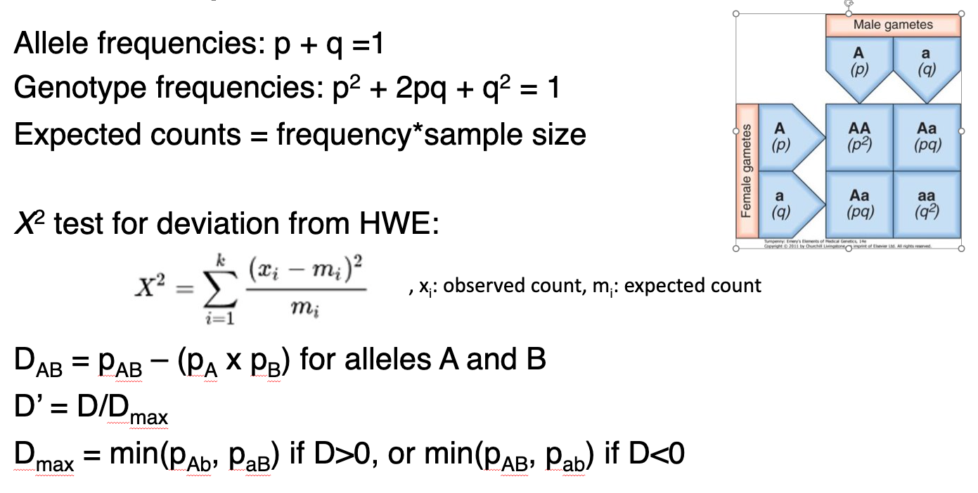

The Hardy-Weinberg Equilibrium (HWE)

- A SNP has the following observed genotype frequencies:

AA | AT | TT
0.400 | 0.463 | 0.137

What are the expected allele frequencies under HWE?

- In a population of 300 individuals (=600 chromosomes, but N = 300), we observe the following distribution of the SNP above. What is the expected genotype distribution under HWE?

 | AA | AT | TT
Observed distribution | 120 | 139 | 41
Expected distribution

- Calculate the $χ^{2}$ test statistic for the above SNP. Is there evidence that the SNP is in HWE?
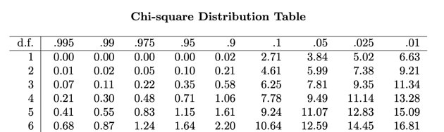

- Is there statistical evidence that the marker is in HWE?

Linkage Disequilibrium:

Consider two loci on the same chromosome: Locus 1 (alleles A and a) and locus 2 (alleles B and b). We observe the following number the respective haplotypes in 500 individuals:

 | AB | Ab | aB | ab
Observed number | 450 | 50 | 100 | 400

Hint: Remember that the number of haplotypes is 2 x N, because each individual carries two copies of each chromosome.

- What are the allele frequencies for each of the four alleles?

- What are the expected haplotype frequencies if the two loci are in linkage equilibrium?

- Calculate the LD coefficient (D) and the standardized LD coefficient (D’) for the alleles A and B. Are these alleles in LD?

